BACKEND SETUP
1. first setup environment all that
2. go inside auramed-backend cd into it
3. then create the file structures with the models
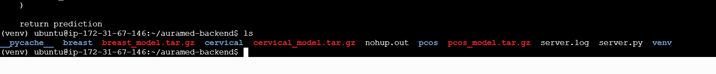
4. server.py create nano and write the file contents
5. ml models inference.py and all the stuffs in the folder (backend setup)

